# HTML – Lesson 8

## INHERITANCE

HTML elements are organized around a hierarchy:

* All elements (expect HTML) have a parent
* An element can have children : its nested elements

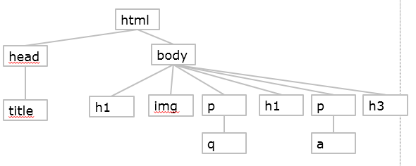

For instance on the above graph: the first P parent is BODY and it contains one child Q

* All elements inherit from the CSS properties of their parents.

For instance on the above graph, if the font for P is defined as Arial, the Q will also have its font defined to Arial: it inherits from the parent properties.

If the BODY element background color is set to BLUE, all element background color will be also BLUE

## OVERWRITING INherited vALUES

You can overwrite the properties you inherit from the parent by specifying a rule for your element:

Let‘s define the following rules :

body { font-family: sans-serif; }

**em { font-family: serif; }**

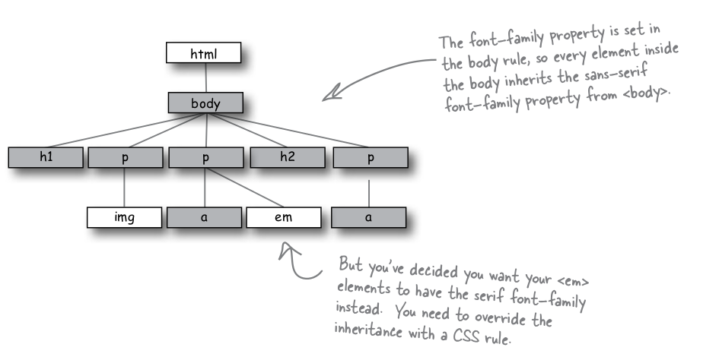

## SPECIFY RULES USING CLASSES

*Classes are used to specify rules for specific elements: for instance you want to set text color to only specific P elements.*

**A class is like a club: you** start a “tennis”, or a “chess” club, and you join to it. By adhering to the club you will agree to all rules and rights of the club. You can also join to several clubs if you like playing tennis, swimming and motorbike.

**To create a class in CSS, you have to use the following rule syntax:**

.pink-mode {

color: pink;

}

* You create the class rule using “.” ( a dot) and the class name
* The rule will be applied to all elements belonging to this class

**To adhere an HTML element to a CSS class, you have to specify the class name in element properties:**

* Just add the attribute “class” :

<p class=“**pink-mode”>** This is a paragraph </p>

* Now my P element belongs to the class pink-mode !

An element can adhere to several classes :

<p class=“**pink-mode center-mode”>** This is a paragraph </p>

* Now my P element belongs to the classes pink-mode and centered-mode !

Let’s say I have 2 elements belonging to my class pink-mode :

<p class=“**pink-mode”>** This is a paragraph </p>

<a class=“**pink-mode”** href=”toto.html**”>**my link</a>

I want the text to be bold if the class is pink-mode AND the element is P (and not if element in A…)

You can specify in the CSS selector, the class name AND the element name:

p.pink-mode { font-weight: bold;}

We write the selector as follow : element-name “.” class-name

* This rules is applied to ALL **elements P** belonging to the **class pink-mode**